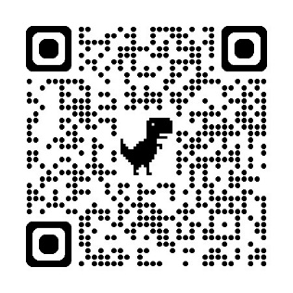
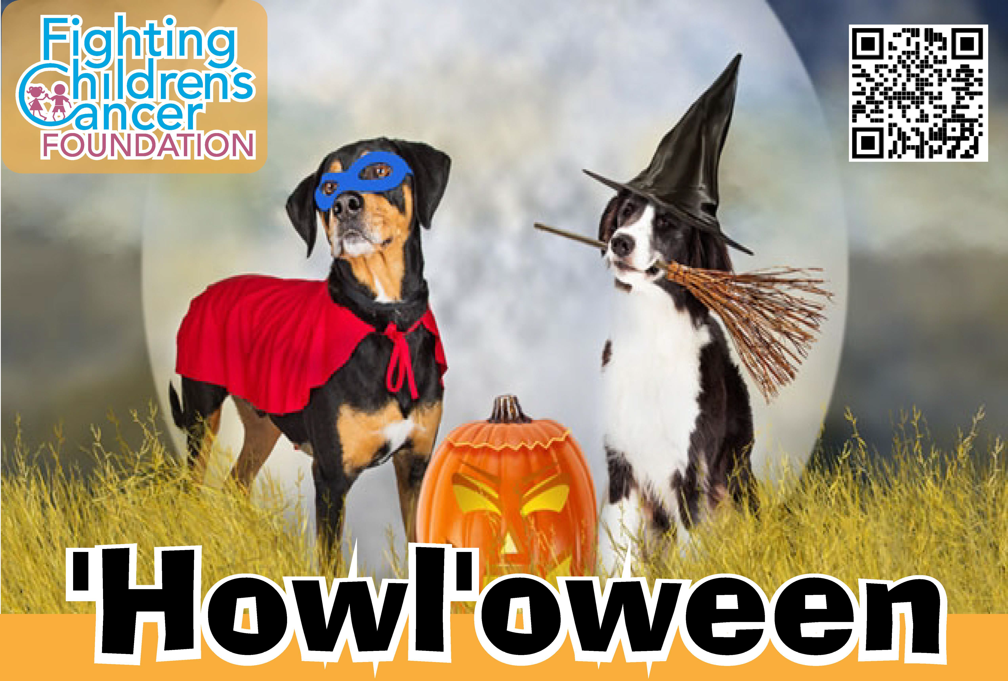
Saturday, Oct. 19, 2024
Central Park of Morris County, Parsippany.
Howl’oween gratefully accepts gifts and gift baskets for our tricky tray
Pet food and toys, coupons, gift certificates, novelties, samples, …or any item fit for a tricky tray.
Donors will receive recognition at the event and in the Howl’oween program.


For more information:
Christian Van Pelt: 973.525.2347, cvanp31@gmail.com
Chelsea Hinkle: 856.906.6052, chelsea.hinkle@gmail.com

https://www.fccf.info/events/howl-2/

